Teepu Khan

Daniel J. Gallegos

May 11, 2017

Test cases:

1. Page reference:20 range:0-7 physical frames:3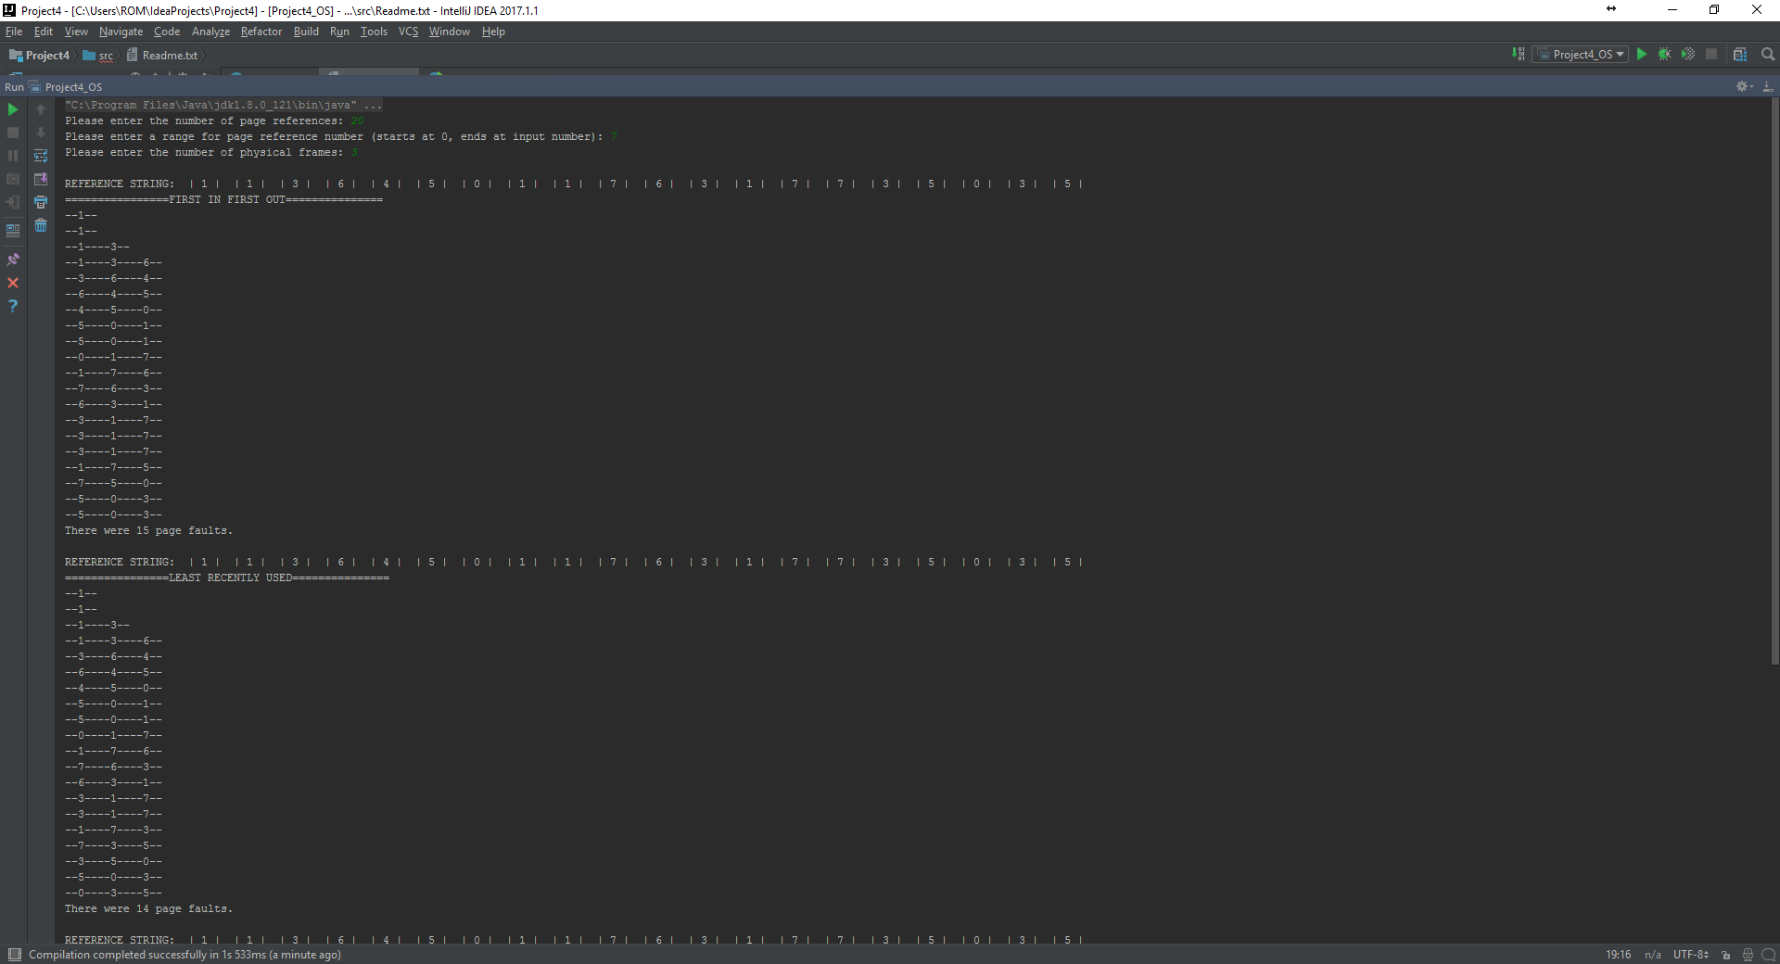

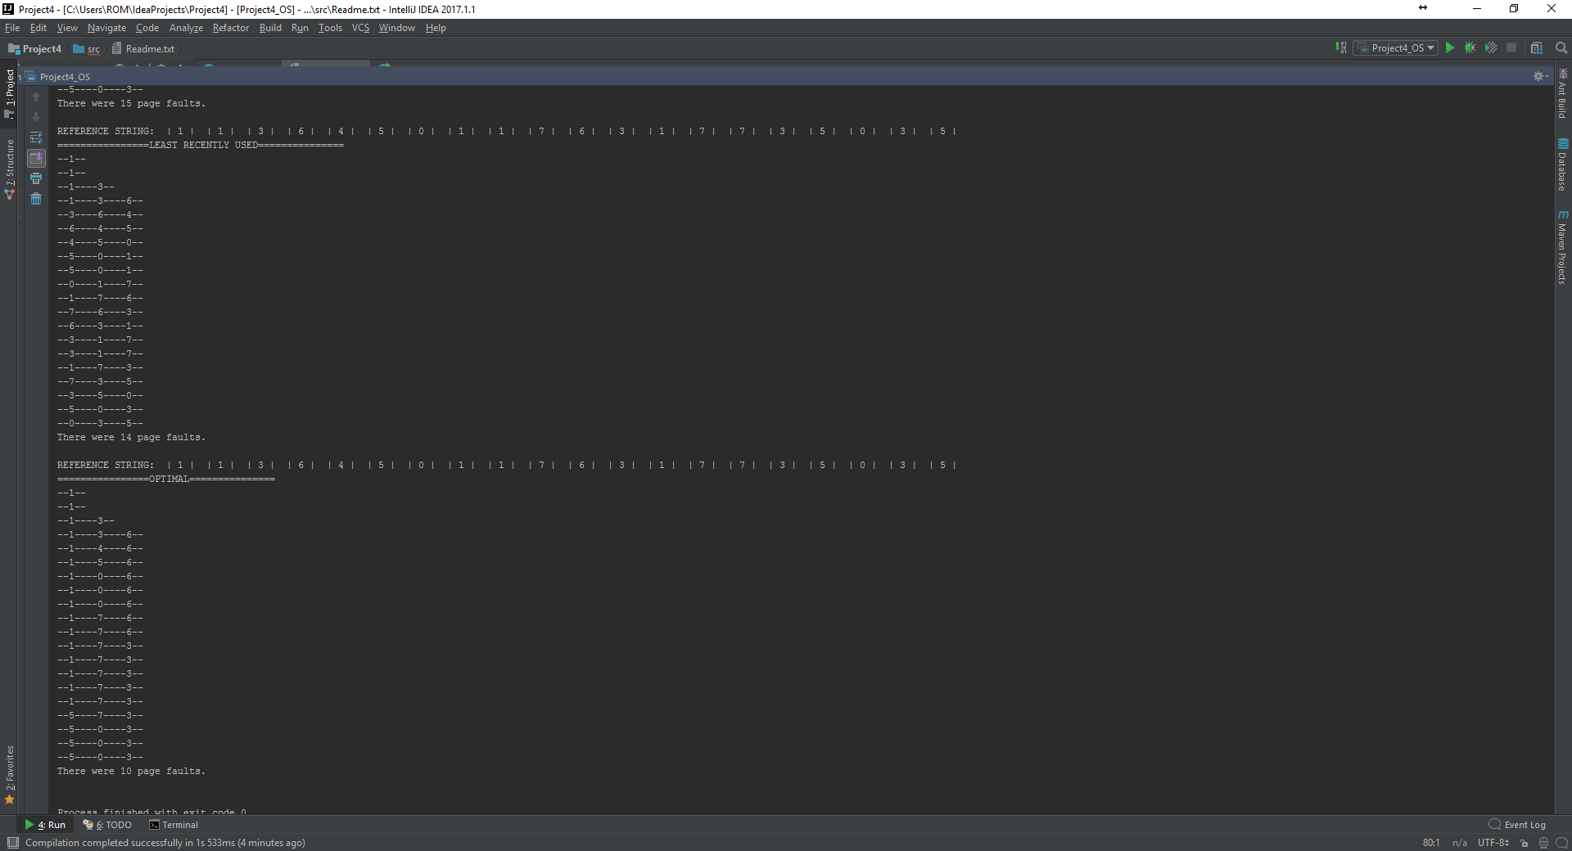

1. Page reference:20 range:0 -7 physical frames:6

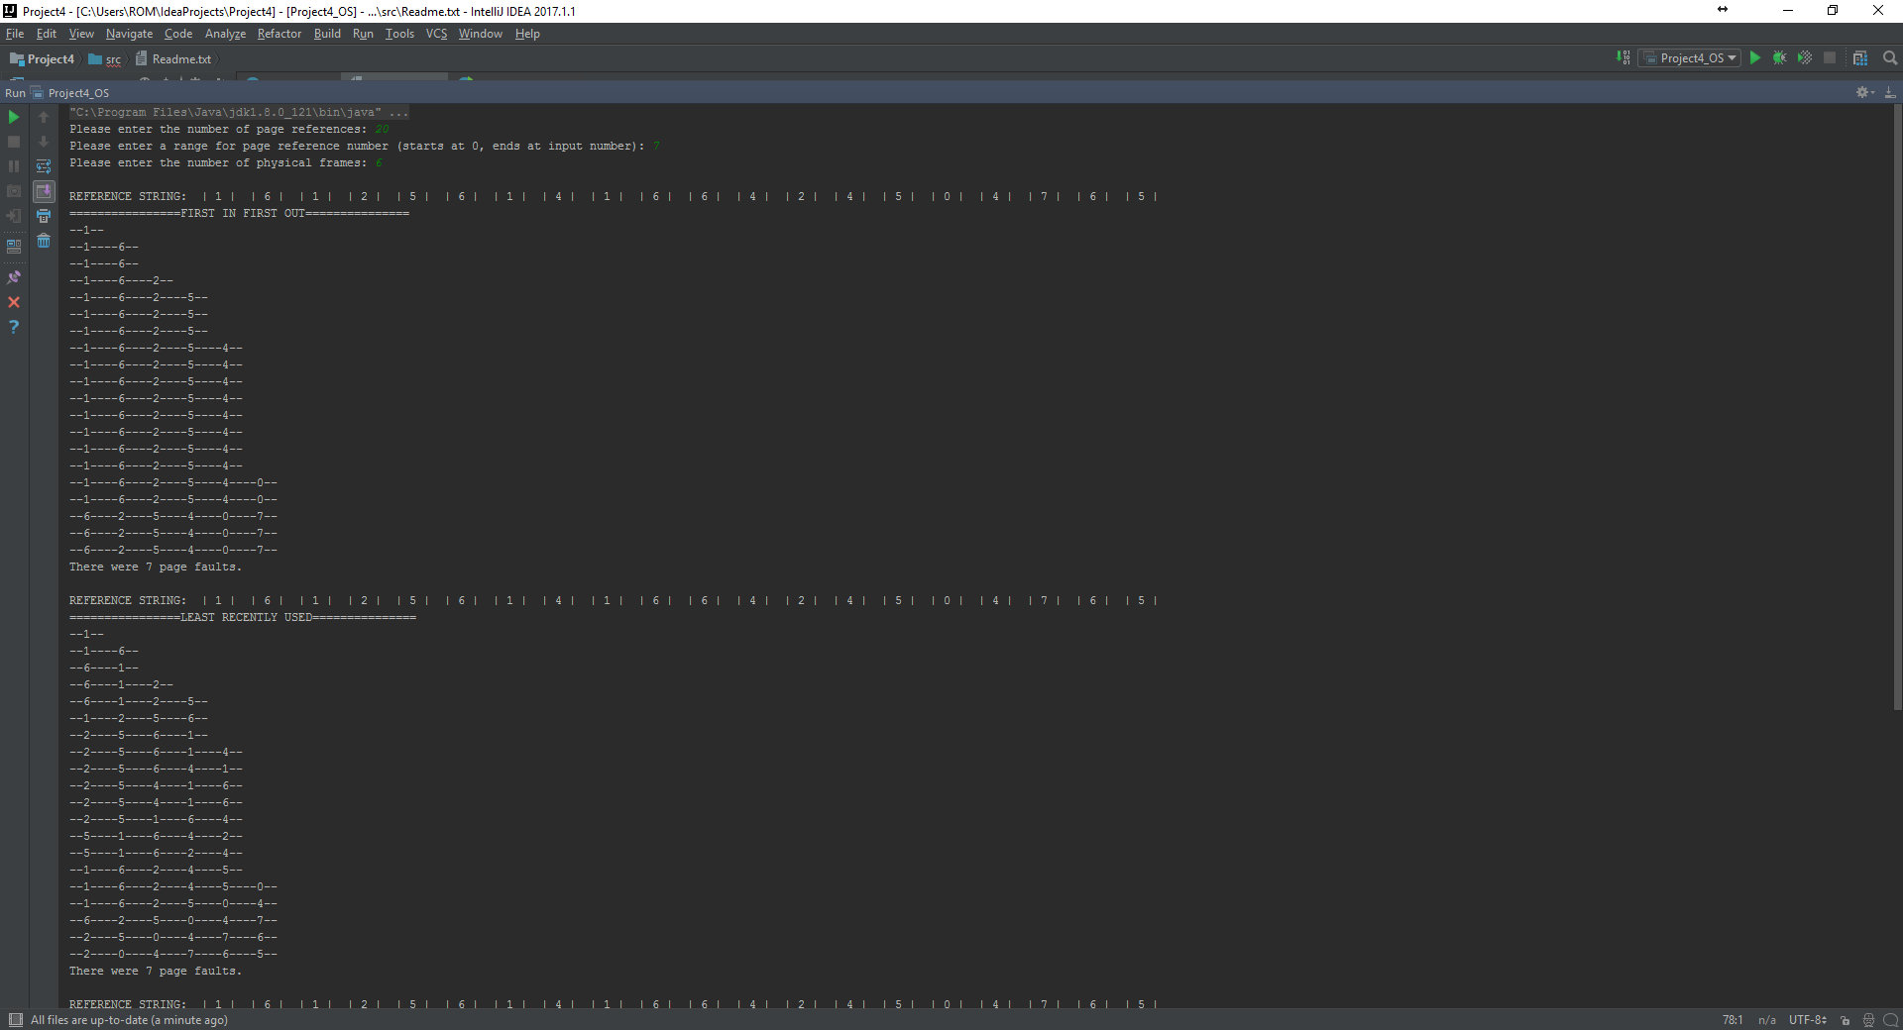

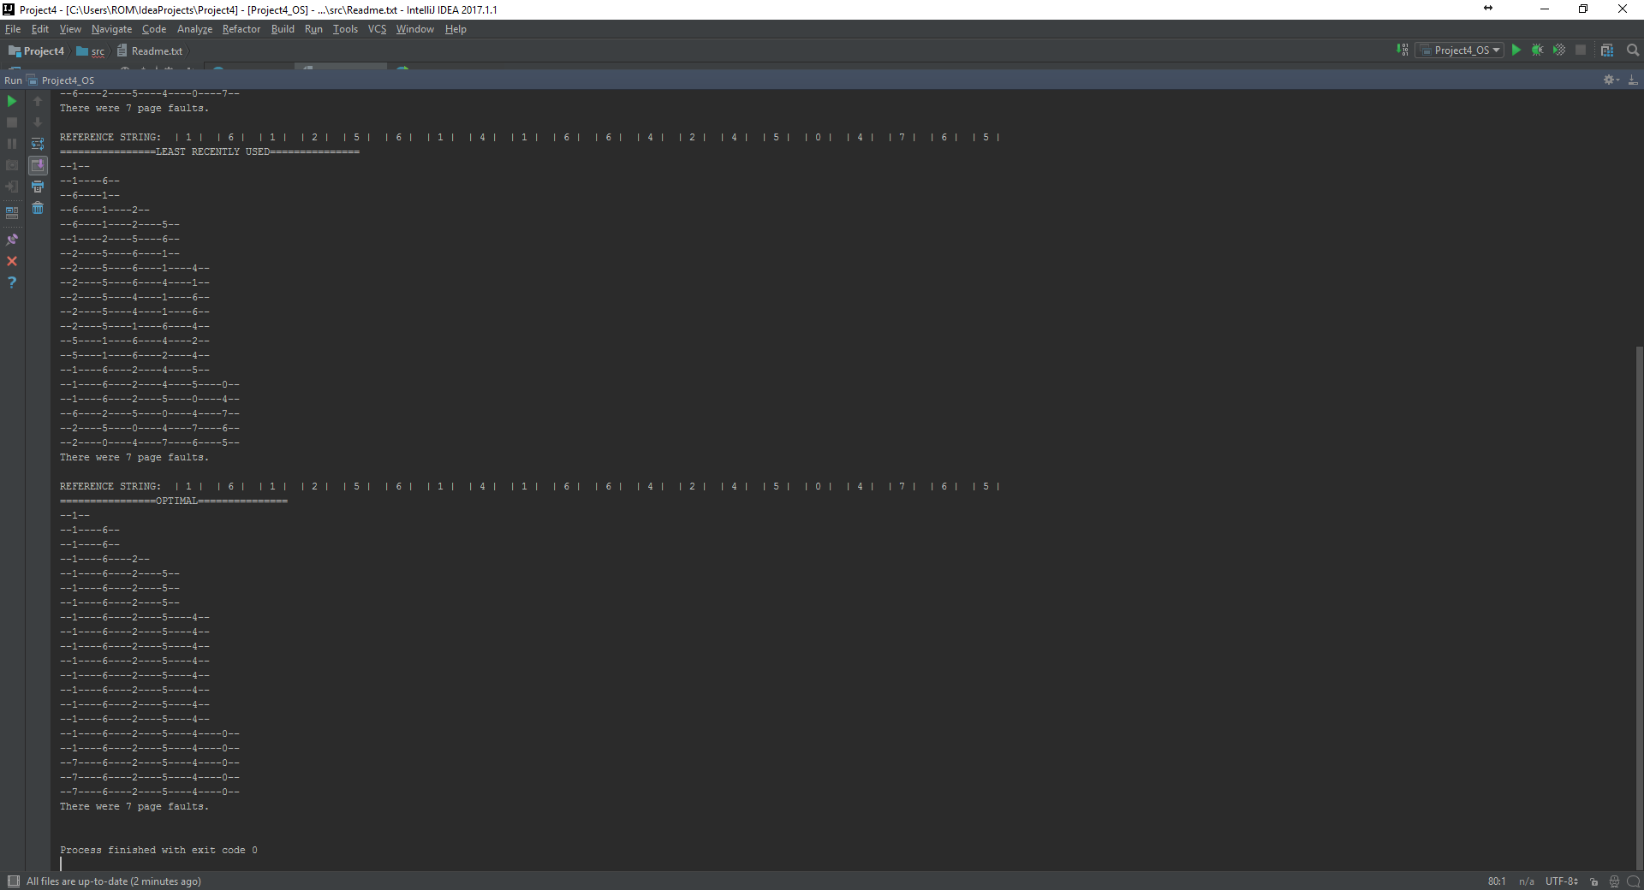

1. Page reference: 20 range:0 -7 physical frames:12

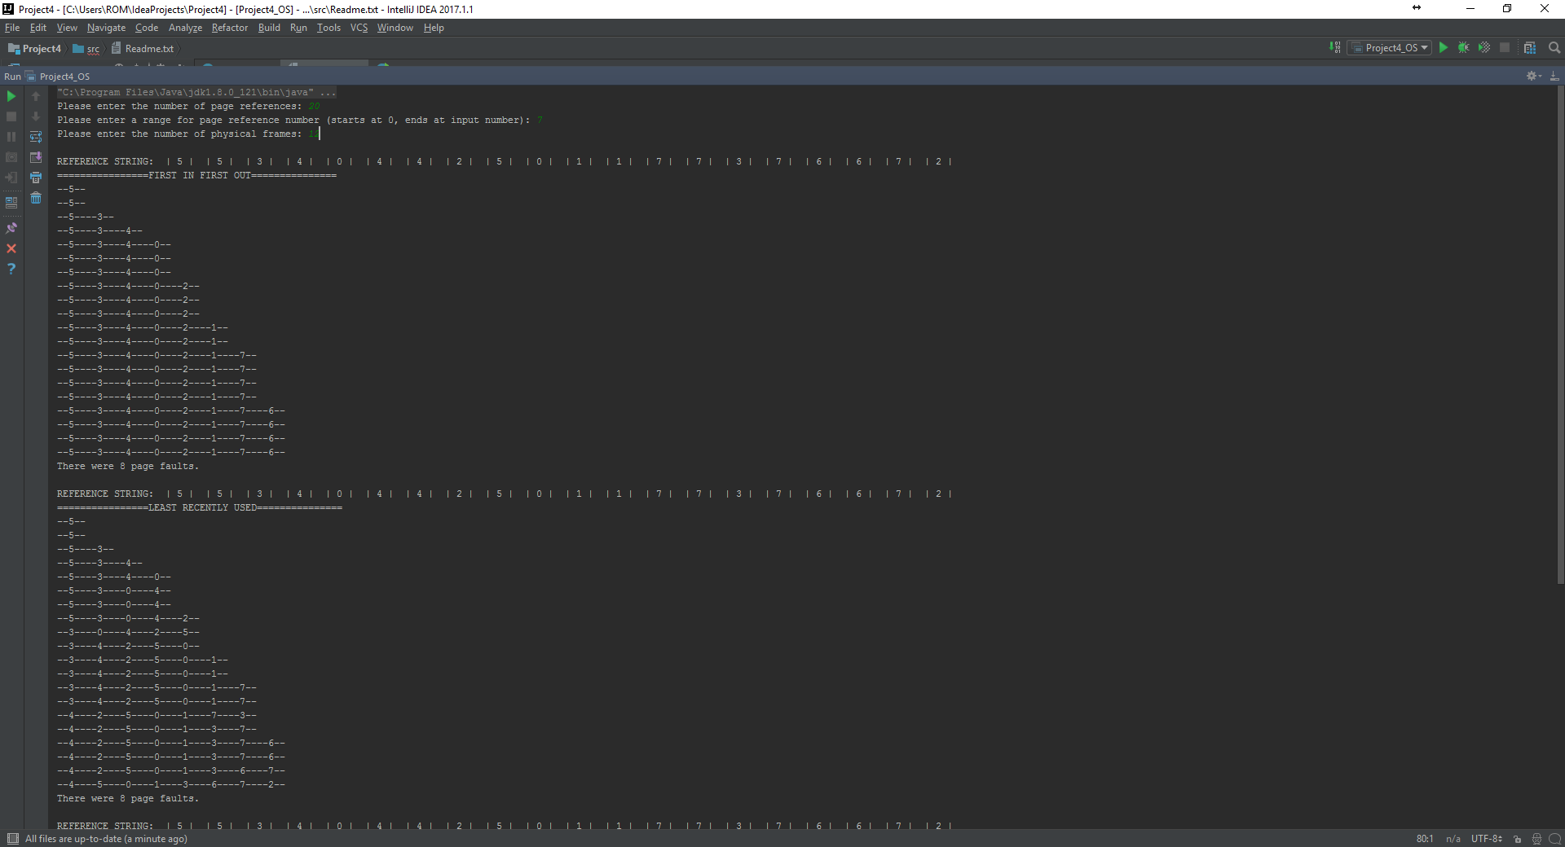

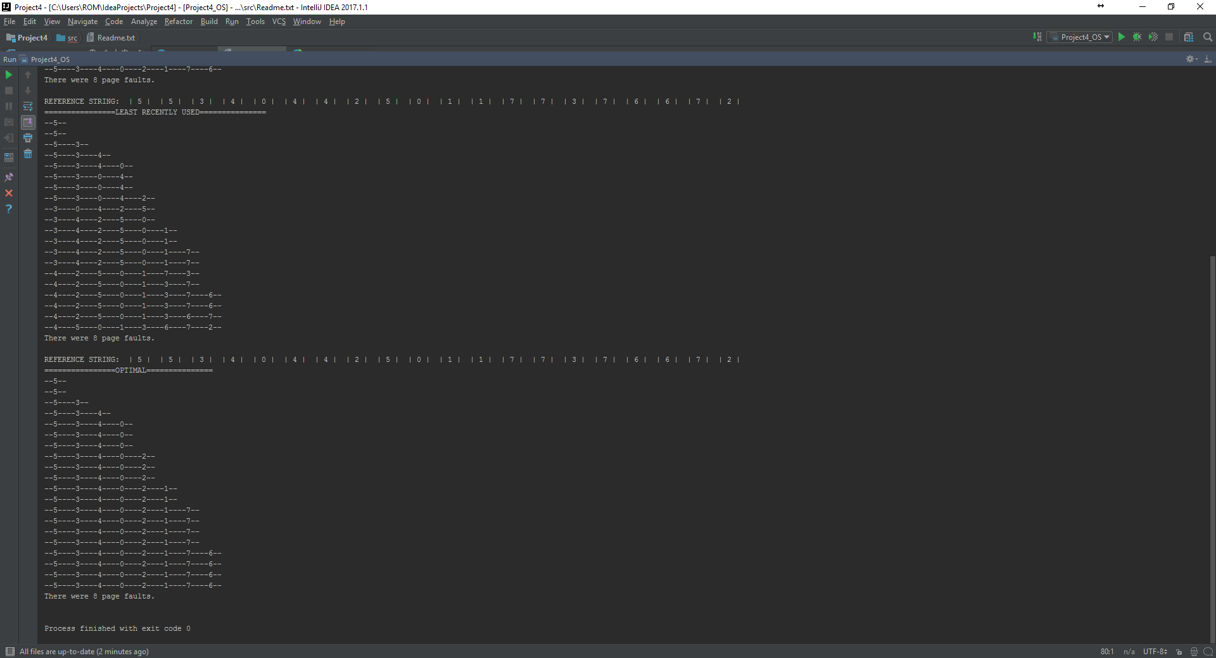

1. Page reference: 20 range:0-7 physical frames:16

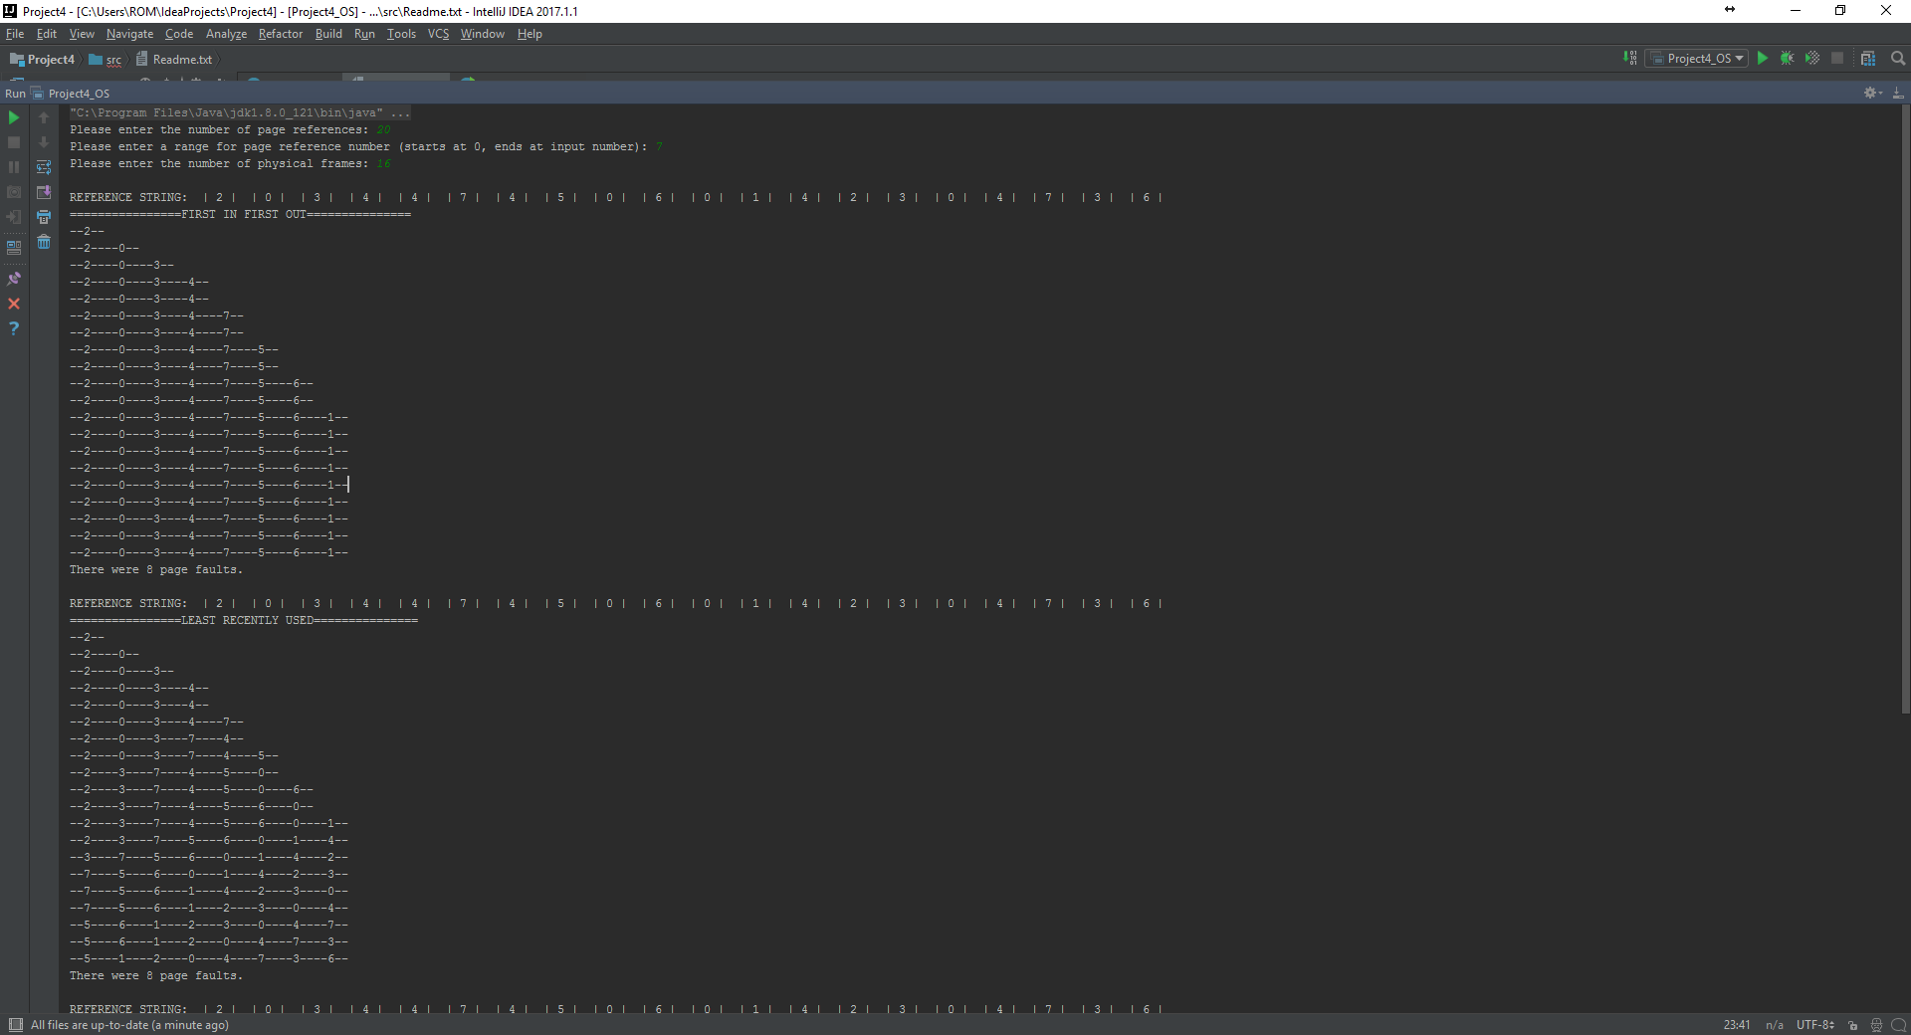

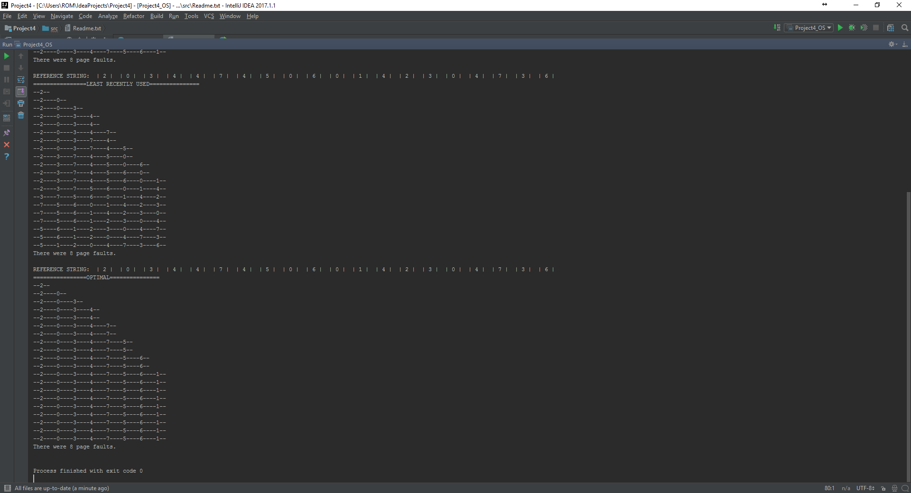

1. Page reference:20 range:0-7 physical frames:18

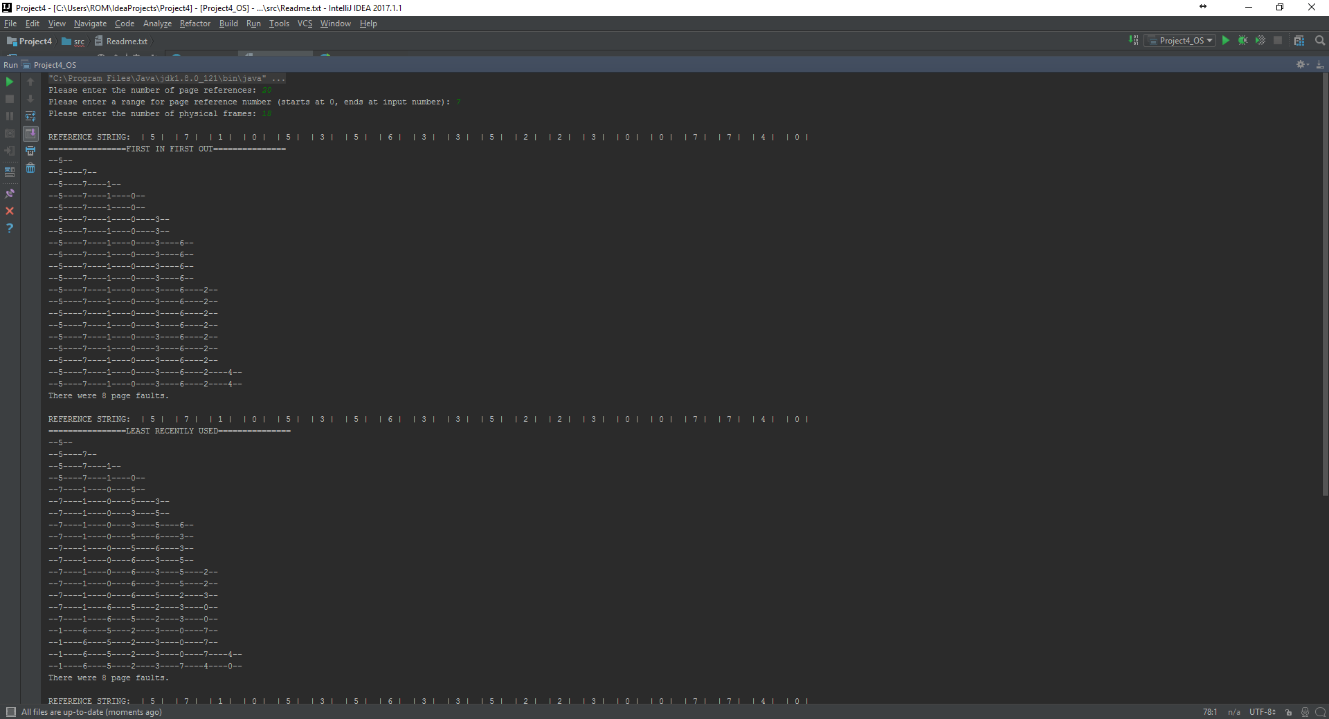

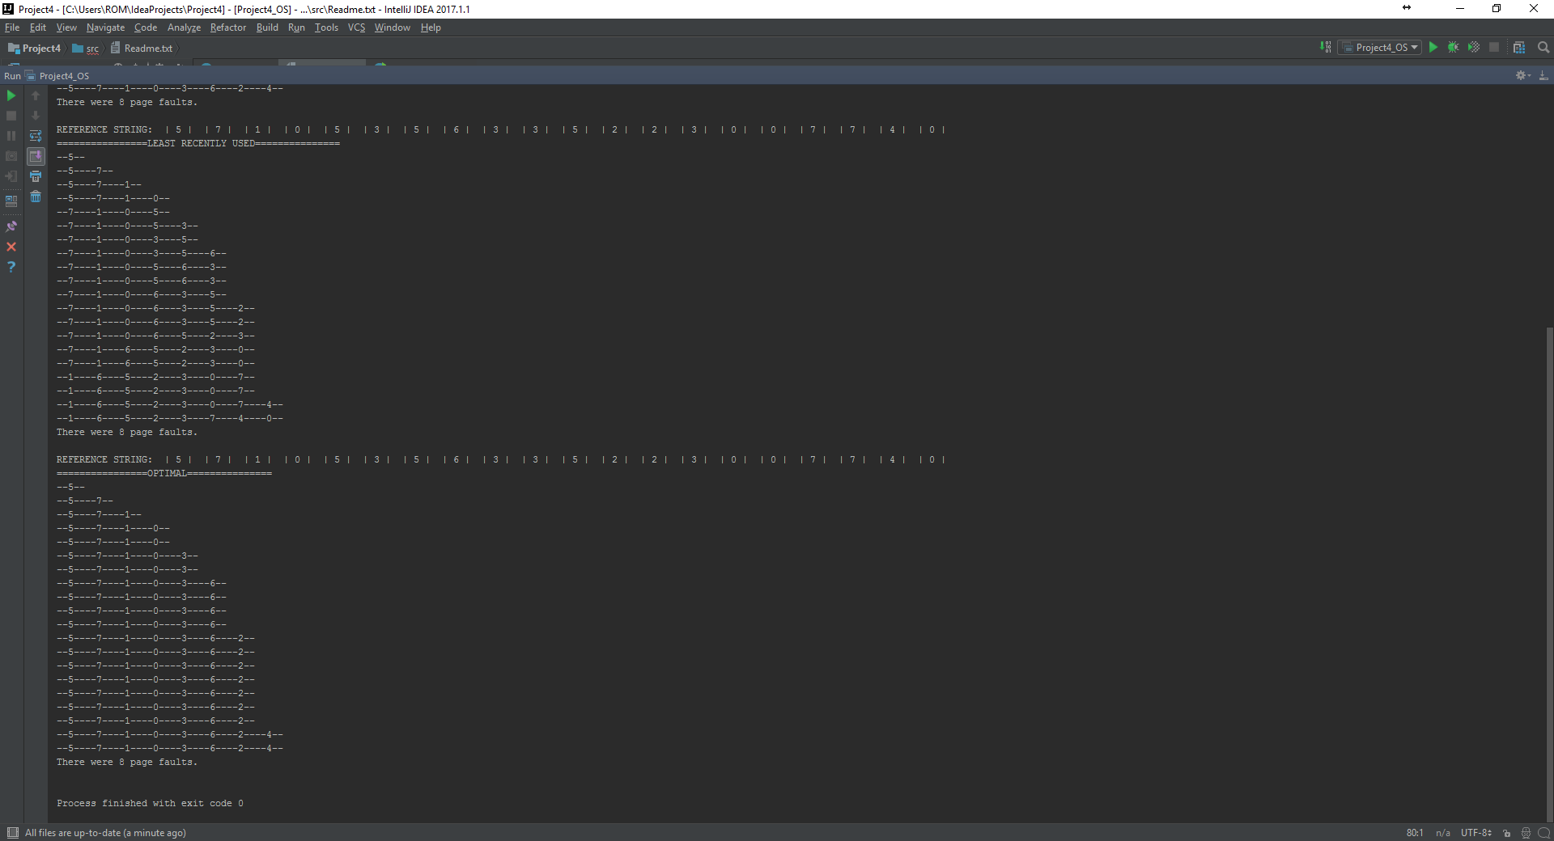

The number of page faults it stabilizes at 8 for the case of 20 page references in the range of 0-7